**Smartinternz Externship**

**Data Analytics with IBM Cognos Analytics**



**ASSIGNMENT - 3**

**Name: MOUNIKA SATYA PRASEEDA KALLAKURI**

**Email ID:** [**praseeda.21bce9173@vitapstudent.ac.in**](mailto:praseeda.21bce9173@vitapstudent.ac.in)

**Registration Number: 21BCE9173**

Step One: Upload the dataset to Mysql and integrate with Tableau.

Removing unnecessary columns from the dataset.

Gender: In most cases, gender might not strongly influence overall sales predictions.

Tax: While tax is relevant to the total price, including it in the analysis might not add much predictive value.

Time: If you're looking at broader trends and patterns, specific purchase times might not be necessary.

Visualizations generated from the provided dataset.

1. Total Quantity by Date, Grouped by Branch"

Total Quantity: This tells the viewer what the vertical axis represents (the sum of quantities).

Date: This specifies the horizontal axis variable, which is the date.

Grouped by Branch: This explains how the data is differentiated or colored in the chart.

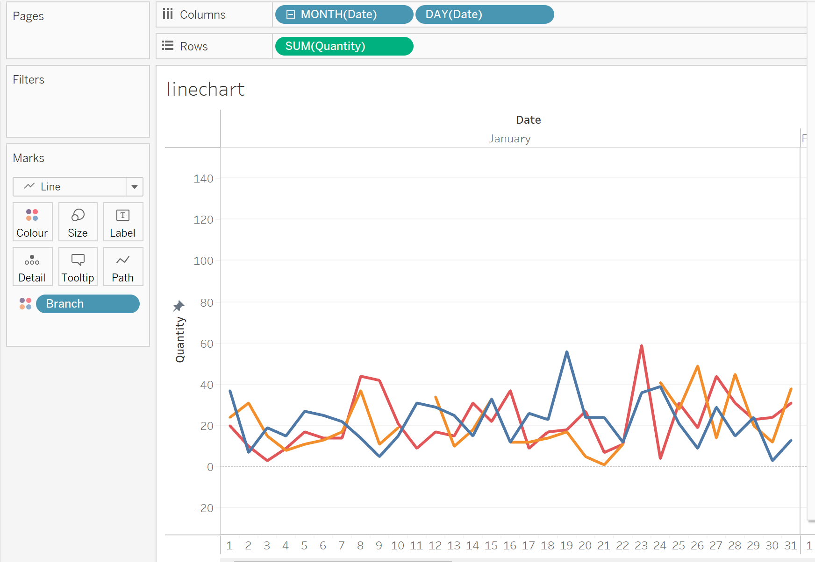

2. Gross Income by product line and Invoice ID.

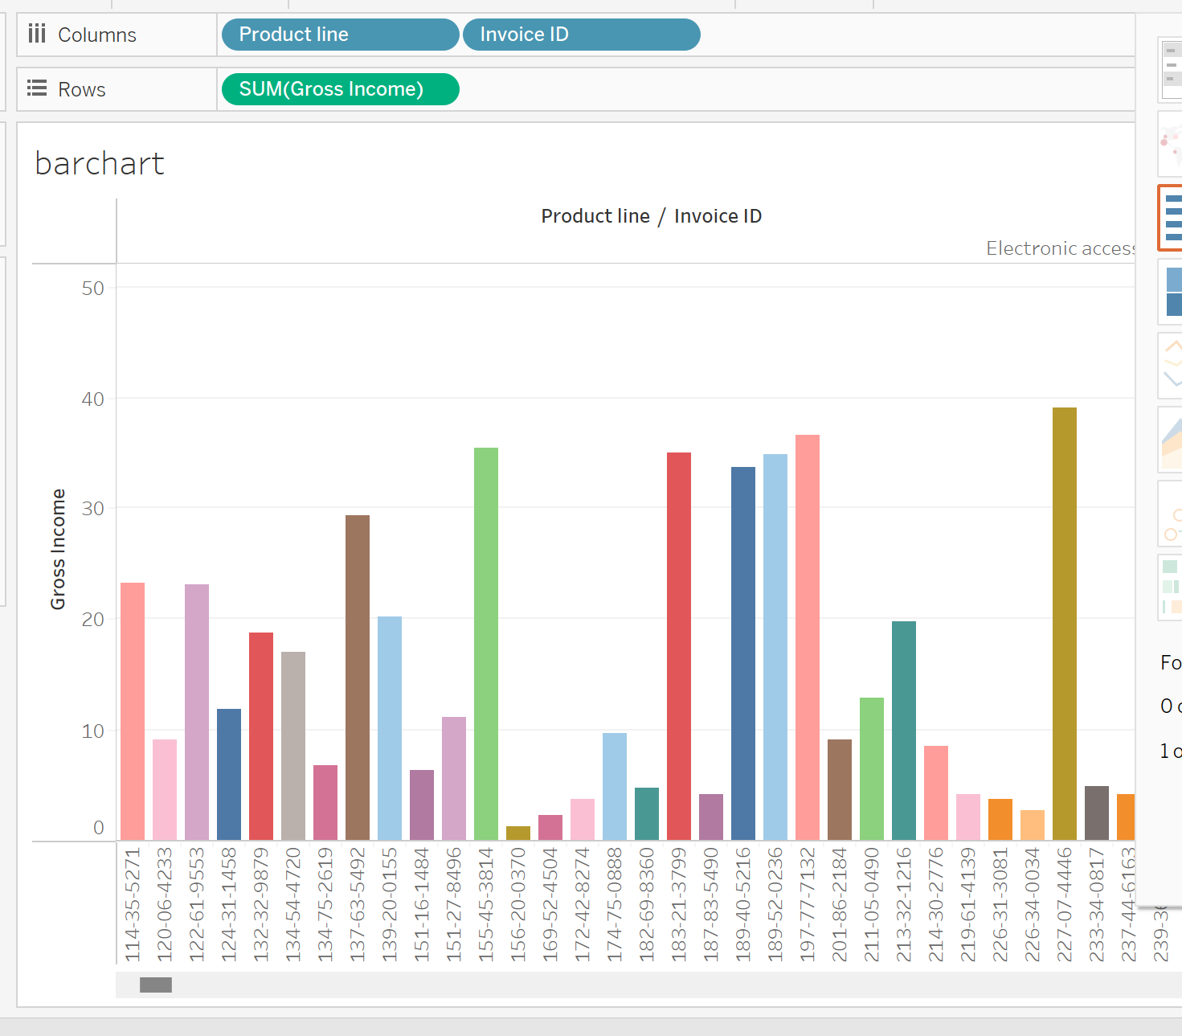

3. Distribution of Total Quantity by Product Line and Customer Type

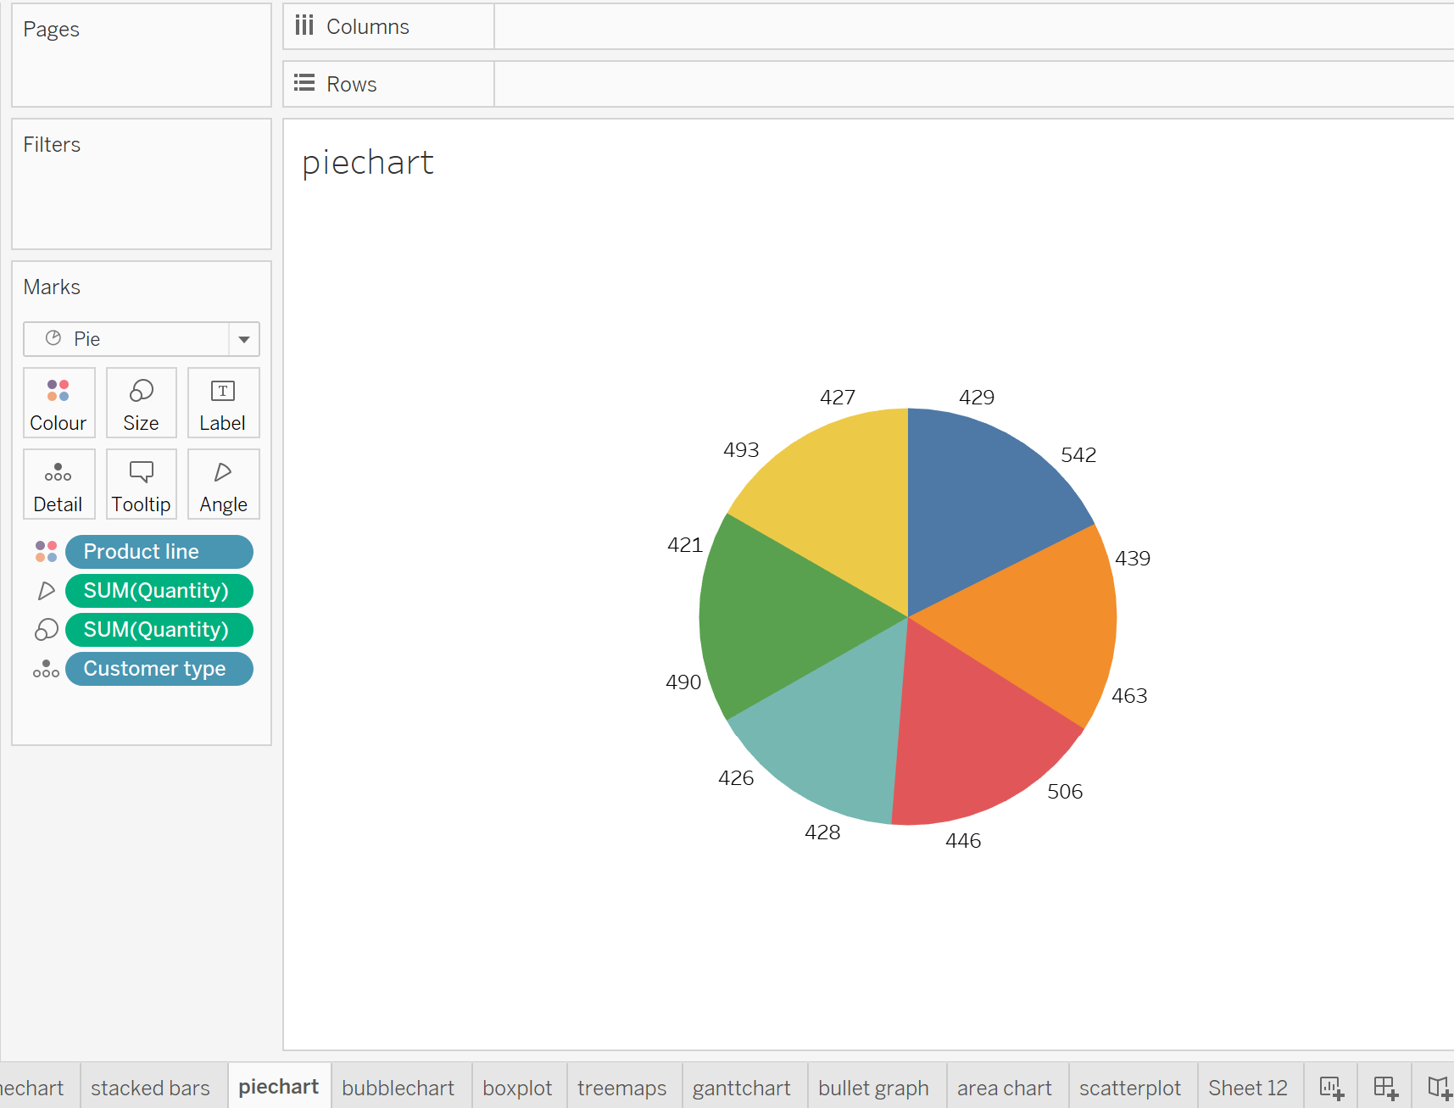

4.Average gross income by product line coloured by customer type and branch.

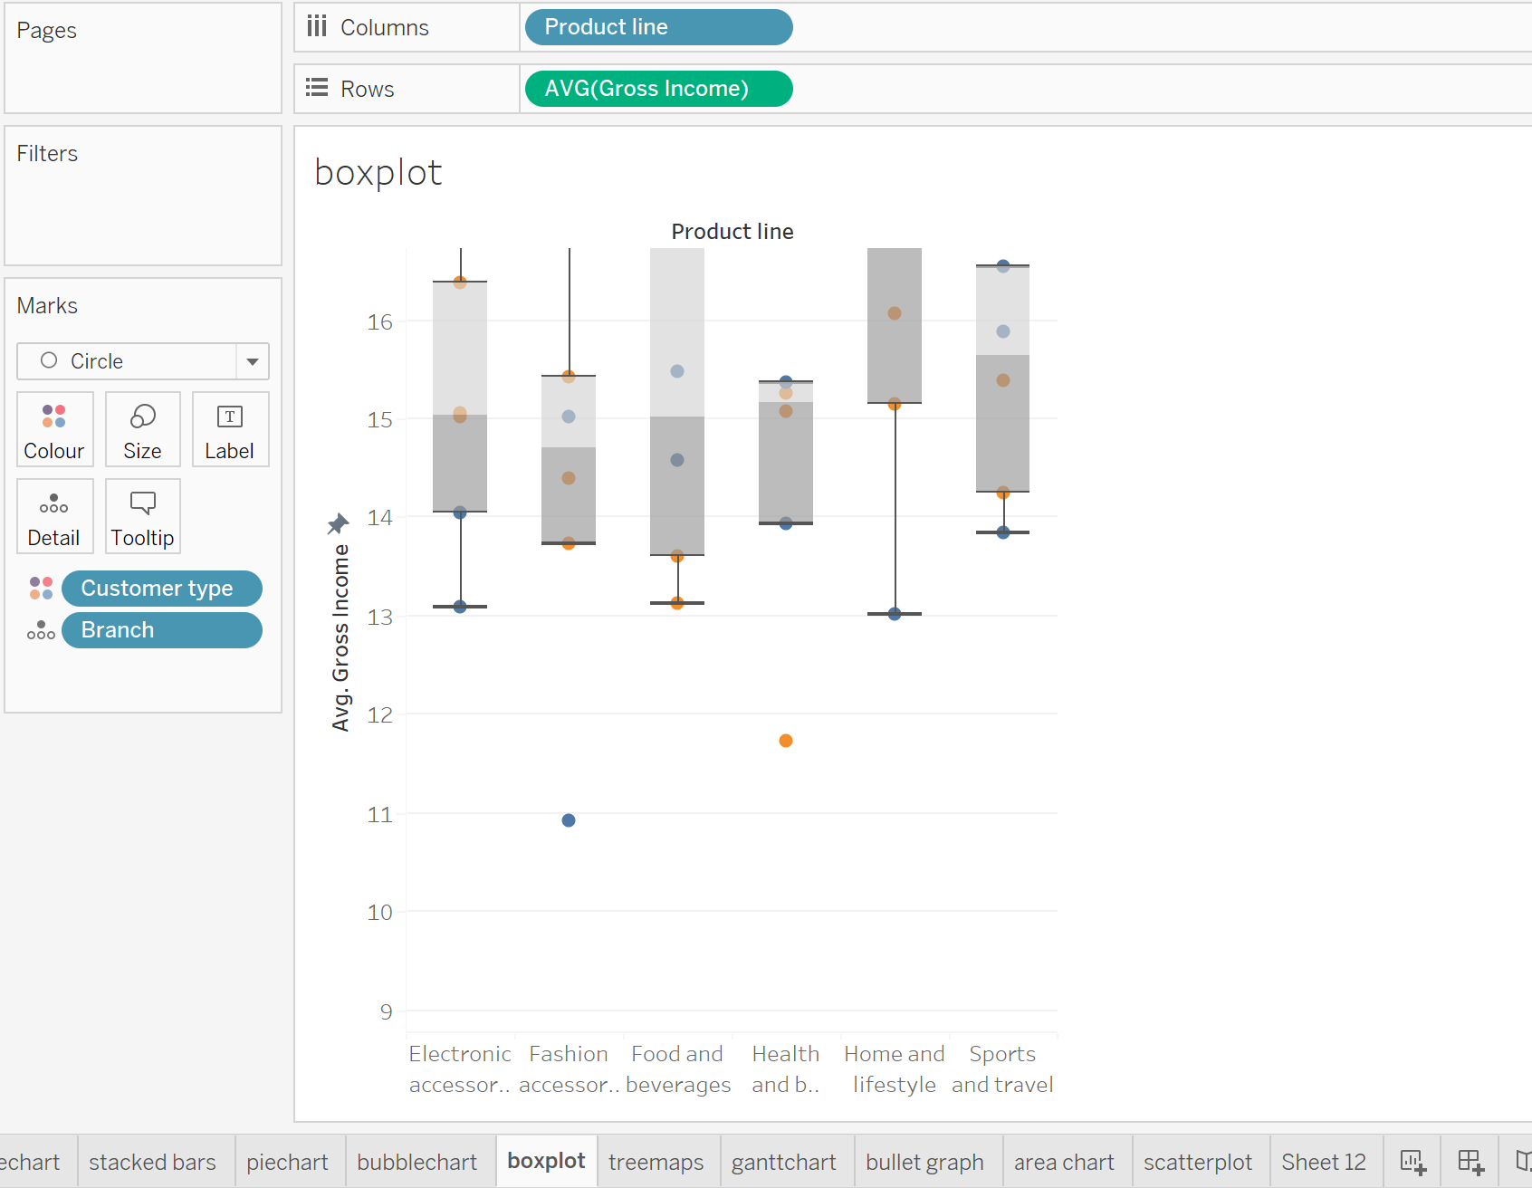

5.treemaps

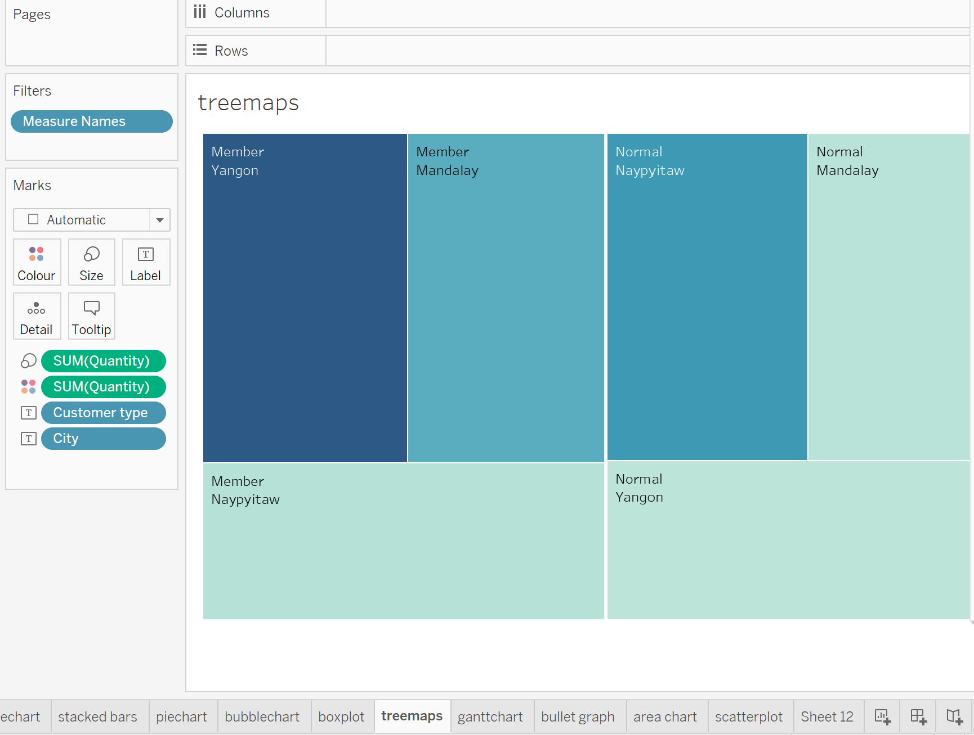

6. area chart

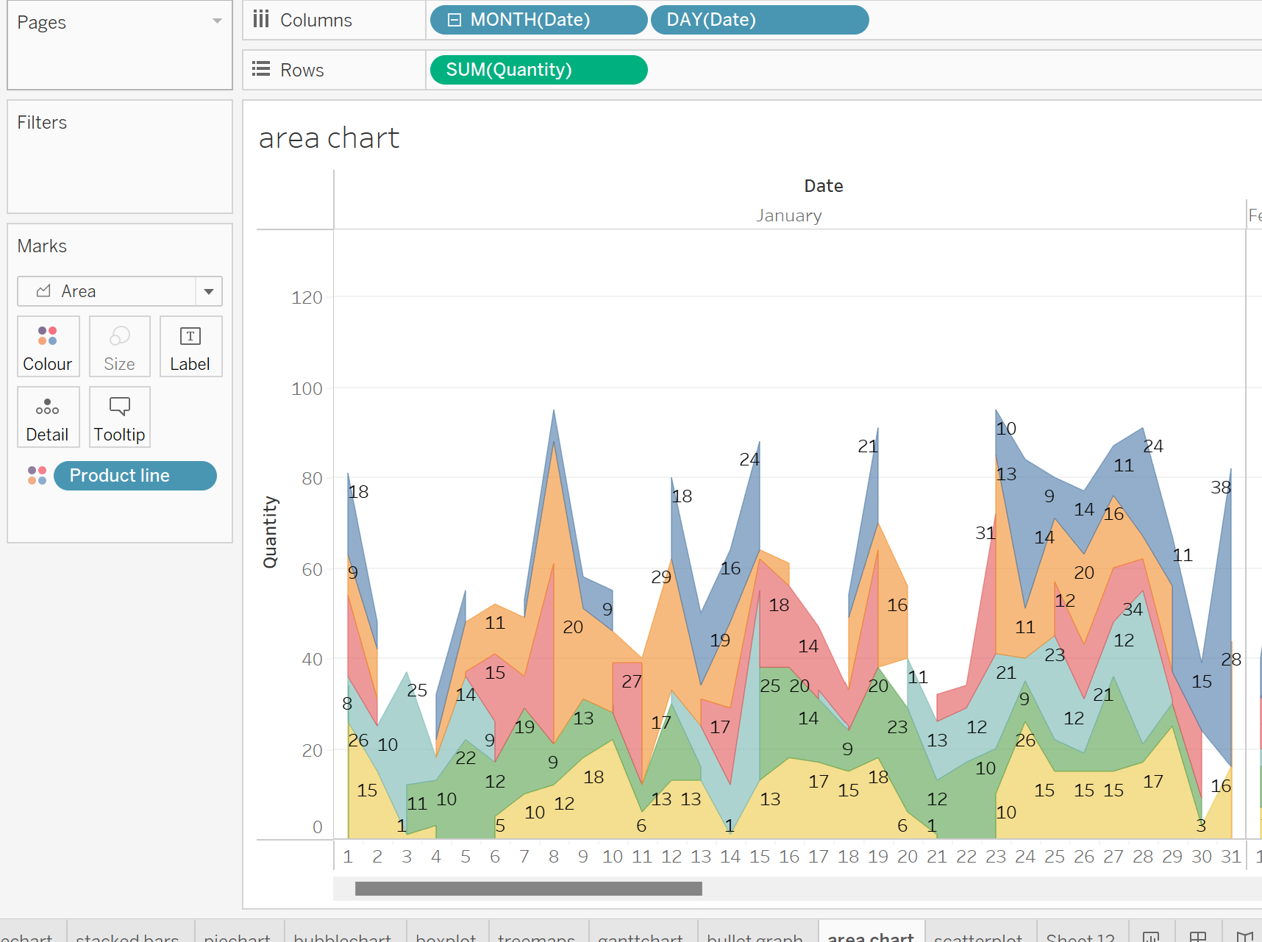

7.SCATTERPLOT

